**Green Society Public School**

**D-20**

**Ratnanagar-7, Sauraha, Chitwan**

**First Terminal Examination-2082**

**Class: U.K.G Time: - 2 hrs. F.M.: 50**

**Sub: Social Science P.M.: 18**

|  |
| --- |
| **Name: Roll No.: Sec.:** |
| **­­­­­­­­­­­­ ________________ ______________ OBT.MARKS:**  **INVIGILATOR EXAMINER** |

1. **Write any 5 Polite words? (5)**

…………………. …………………. ……………………….

…………………….. ……………………

1. **Match the same family members. (5)**

|  |  |  |
| --- | --- | --- |
| Handsome Grandfather Coloring Pages |  | Sister |
| Grandmother Line Drawing SVG Cut file by Creative Fabrica Crafts · Creative  Fabrica |  | Mother |
| Man Smiling - Father Or Dad | Royalty-Free Vector Stock | FreeImages |  | Grandmother |
|  |  | Grandfather |
| Sister |  | Father |

1. Write name of road transportation? (5)

…………………. …………………… …………………….

…………………….. …………………..

1. 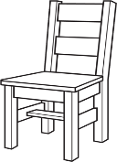**Write name of the given picture. (5)**

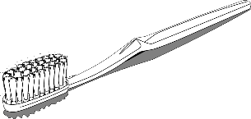

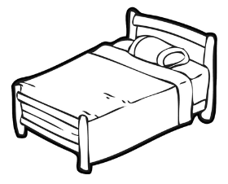

1. **Write the name of Community helpers. (5)**

………………….. ………………….. ………………….

…………………. …………………..

1. **Write the name of body parts. (5)**

………………….. ………………….. ………………….

…………………. …………………..

1. **Write the name of living things. (5)**

………………….. ………………….. ………………….

…………………. …………………..

1. **Circle the word that matches with the picture of sense organs. (5)**

|  |  |  |  |  |
| --- | --- | --- | --- | --- |
| Eye Black And White Vector Art, Icons, and Graphics for Free Download | Lie | Eye | Pie | Ear |
|  | Sung | Lung | Tongue | Tung |
|  | Fear | Near | Dear | Ear |
|  | Rose | Rose | Pose | Jose |
|  | Skin | Ear | Eye | Nose |

1. **Write the name of the domestic animals. (5)**

……………………. ……………………. …………………….

……………………. …………………….

1. **Mach the following. (5)**

Fruit

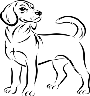Vegetable

Insect

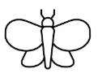Bird

Animals

Flowers

**The End**